Visualization
  - Appropriate plot for the RQ output of an R script and required supplementary graph/table

USA: Proportion of Gender within Income Brackets
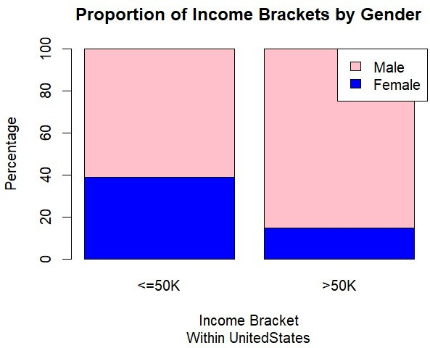
USA: Income category Distribution within Genders
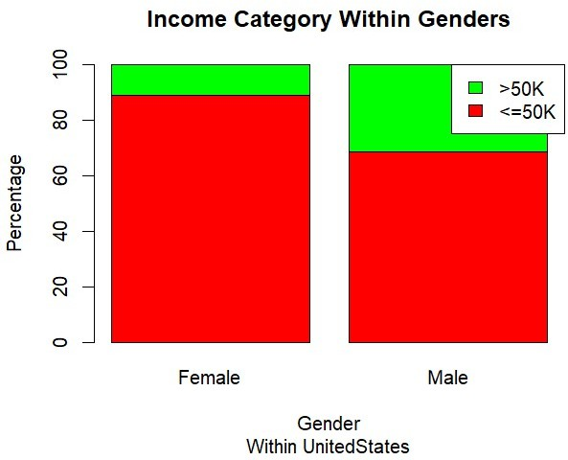

Contingency table

United states: Sex vs Income Bracket Contingency table

 | <=50K | >50K
Female | 8594 | 1068
Male | 13371 | 6087

Sample size: n = 29,120
Female: 9,662 total (93.3% earn <=50K)
Male: 19,458 total (68.7% earn <=50K)
Finding: A noticeably higher proportion of males earn >50K compared to females.
    - We’ll use a chi-square test to examine whether there’s a link between two categorical variables, such as reason for absenteeism and age group. Since this test is non-parametric and works with nominal data, it doesn’t rely on data distribution, so a histogram isn’t needed.

  - Additional information relating to understanding the data

The bar plot clearly shows that males have a larger green section, meaning more of them earn over 50K. The contingency table supports this with actual numbers, confirming that the pattern seen in the chart is backed by data and suitable for the chi-square test.

  - Useful information for the data understanding

The plot clearly shows that most women fall into the ≤50K income group, while men appear more often in the >50K range. Although both genders mostly earn below 50K, men are still more likely to be high earners. This trend suggests gender may influence income levels.

Analysis
  - Statistical test used to test the hypotheses and output

We used the Chi-Square Test because both gender and income bracket are categorical. We wanted to see if men and women have different chances of being high earners in USA. The test checks if the differences we see are bigger than what we’d expect by chance. It doesn’t need normally distributed data, which makes it great for big datasets like Adult Income. The test gives a chi-square value, degrees of freedom, and a p-value.

  - The null hypothesis is rejected /not rejected (select one) based on the p-value.

The chi-square test for the USA data returned a very small p-value (p < 2.2e⁻¹⁶), meaning it’s extremely unlikely that the differences we see happened by chance. Because of this, we reject the null hypothesis. This shows a clear relationship between gender and income bracket. Males are much more likely to earn over 50K, while females are mostly in the ≤50K group. These results match what we observed in both the bar chart and the contingency table, supporting the idea that gender influences income levels in this dataset.

